Machine Learning Algorithms with Use Cases Examples

*Machine Learning algorithms and their specific purpose. ☺*

1. ***Supervised Learning***

In the Supervised Learning purpose, “***develop predictive model based on both input and output data***”. Algorithms are trained explicitly through direct human supervision.

The algorithm receives both the input and output data. The algorithm then begins to create rules mapping the input to the output. This training process continues until the highest level of performance is reached. “The aim here is to train an algorithm to assign or predict output objects with which it has not interacted during the training process”.

So the developer can choose from the model that best predicts the desired output.

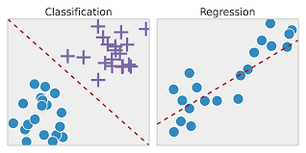

**The most common use cases of supervised learning are predicting future trends in sales, price and stock market.** **Examples of supervised algorithms include**

1. Logistical Regression
2. Neural Networks
3. Linear Regression
4. Decision Trees
5. Random Forest
6. Support Vector Machines (SVM)
7. Naive Bayes
8. Polynomial

**There are two supervised learning techniques :**

**i) Regression :** Regression used for prediction of products and stocks. “ Identifies the patterns in the sample data ”. calculates the predictions of continuous outcomes. That’s the purpose as understand the numbers, their values, their correlations or groupings.

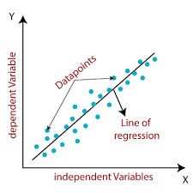

Fig. Linear Regression

**ii) Classification :** Classification is used to identify objects, determine if a mail is spam or not, make weather forecasts etc. “Historical data samples and is then manually trained to identify particular types of objects”.

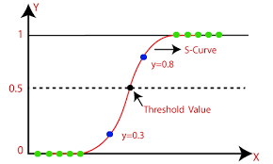

Fig. Logistical Regression

* **Different points in both techniques**

**1) Regression :**

|  |
| --- |
| **i) Linear Regression** |
| **ii) Polynomial** |
| **iii) SVR** |
| **iv) Decision Trees** |
| **v) Random forest** |
| **vi) KNN** |

**2) Classification :**

|  |
| --- |
| **i) Logistic Regression** |
| **ii) Naive Bayes** |
| **iii) SVM** |
| **iv) Decision Trees** |
| **v) Random forest** |
| **vi) KNN** |

***2)* Unsupervised Learning**

In the Unsupervised Learning purpose, “***Group and interpret data based only on input data***”. Unsupervised learning used to explore the internal structure of data and extract valuable insights from it*.*

Unsupervised learning is used by businesses to extract meaningful insights from raw data to improve operational efficiency and other business metrics.

* **The most popular unsupervised algorithms are** K-means Clustering, Association Rule, t-SNE (t-Distributed Stochastic Neighbor Embedding), and PCA (Principal Component Analysis).

**1)** **Clustering :**

**“**Clustering is an exploration technique used to categorize data into meaningful groups**”**. Clustering is used to group tweets featuring similar content, segregate the different types of news segments, etc.

Clustering is also used to reduces the dimensionality of the data when you are dealing with a copious number of variables. Grouping similar entities together help profile the attributes of different groups.

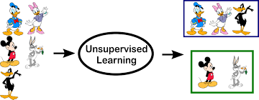

* **most popular and widely used algorithms :**

